Introduction to Web Design
CSS Reference

Inline Style Syntax:

<selector style="property:value;">

Example: <p style="color:red;">Text</p>

Internal Style Sheet Syntax:

selector {property: value;}

Example:

<head>
...
<style type="text/css">
p {
color: red;
}
</style>
</head>

External Style Sheet Syntax:

selector {property: value;}

Example (XHTML document):

<head>
<link rel="stylesheet" type="text/css" href="style.css" />
...
</head>

Example (CSS style sheet):

p {
color: red;
}

Comment Syntax:

/* This is a CSS comment. */

Shorthand Syntax:

padding/margin: <all four sides>
padding/margin: <top and bottom> <right and left>
padding: <padding-top> <padding-right> <padding-bottom> <padding-left>
margin: <margin-top> <margin-right> <margin-bottom> <margin-left>
border: <border-width> <border-style> <border-color> (all four sides)

Examples:

padding: 10px;
margin: 10px 5px;
padding: 20px 10px 5px 15px;
margin: 5px 10px 15px 0px;
border: 2px solid black;

Classes and IDs Syntax:

#idname {property: value;}
.classname {property: value;}

Example:

#idname {
text-align: center;
}
.classname {
font-style: italic;
}
...
<p id="idname" class="classname">Text</p>

CSS Cascade Rank:

- Inline style (highest priority)
- Internal style sheet (second priority)
- External style sheet (third priority)
- Web browser default (only if not defined elsewhere)

CSS 2.1 Color Names and Hex Codes:

White #FFFFFF Silver #C0C0C0 Gray #808080 Black #000000
Red #FF0000 Maroon #800000 Yellow #FFFF00 Olive #808000
Lime #00FF00 Green #008000 Aqua #00FFFF Teal #008080
Blue #0000FF Navy #000080 Fuchsia #FF00FF Purple #800080
Orange #FFA500
Web-Safe Fonts:

Sans-serif:

Arial
Arial Black
Century Gothic
Comic Sans MS
Lucida Sans Unicode
Tahoma
Trebuchet MS
Verdana
Serif:

Book Antiqua
Courier New
Georgia
Palatino Linotype
Times New Roman

Box Model:

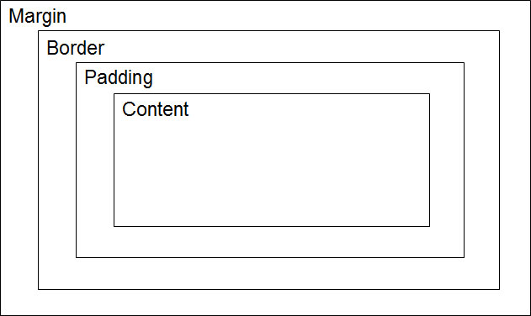

CSS Validation:

http://jigsaw.w3.org/css-validator/ [Choose CSS Level 2.1]

CSS  Property | Description | Common  Values
background-color | Sets the background color of the content and padding area of an element. | <color name>  <#Hex code>
background-image | Sets a background image for an element. By default, image will tile horizontally and vertically to fill the space available. | <file location>
background-repeat | Determines if background image tiles to fill the available space. | no-repeat, repeat  repeat-x, repeat-y
border-collapse | Determines if table cells share a common border or maintain their own borders. | collapse  separate
border-color | Sets the color of the border of an element. | <color name>  <#Hex code>
border-style | Defines a paragraph of content with white space above and below the content. | none, solid, dashed, dotted, double, inset, outset, groove, ridge
border-width | Sets the thickness of the border of an element. | <number of pixels>  thin, medium, thick
border | Shorthand property to set the border between an element’s padding and margin. See Shorthand Syntax section. | <border width> +  <border style> +  <border color>
bottom | Used in conjunction with the position property, moves an element up from its default location. | <number of pixels>  <number in percent>
clear | Discontinues elements from being displayed alongside floated elements, forcing them to the next empty line. | none, both  left, right
color | Defines the color of text within an element. | <color name>  <#Hex code>
float | Determines if other elements will display alongside an element instead of below it. | none  left  right
font-family | Sets a preference list of fonts to be used for affected text. If first choice is not available, second choice will be used, and so on. | Arial, Tahoma, Verdana, Georgia, “Times New Roman”, sans-serif, serif
font-size | Specifies the font size of text. | <size in pixels>  <size in percentage>  xx-small, x-small, small, medium, large, x-large, xx-large
font-style | Determines if text is displayed in italics or not. | italic  normal
font-weight | Determines if text is displayed in bold or not. | bold  normal
CSS  Property | Description | Common  Values
height | Defines the vertical height of an element. | <number of pixels>  <number in percent>
left | Used in conjunction with the position property, moves an element right of its default location. | <number of pixels>  <number in percent>
margin | Shorthand property to set the space between an element’s border and outer edge. See Shorthand Syntax section. | <number of pixels>  <number in percent>  auto
padding | Shorthand property to set the space between an element’s content and border. See Shorthand Syntax section. | <number of pixels>  <number in percent>  auto
position | Determines the position of an element in a web document. Used in conjunction with bottom, top, right, and left properties. | absolute, fixed,  relative, static
right | Used in conjunction with the position property, moves an element left of its default location. | <number of pixels>  <number in percent>
text-align | Determined the horizontal location of an element (not just text) on the page. | center, justify,  left, right
text-decoration | Defines whether text has any special features. | blink, line-through,  none, overline, underline
top | Used in conjunction with the position property, moves an element down from its default location. | <number of pixels>  <number in percent>
width | Defines the horizontal width of an element. | <number of pixels>  <number in percent>
z-index | Sets the visual priority of elements that overlap on the screen, determining which ones are “on top” of others. | <integer>

